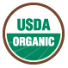

Organic Versus Non-Organic

Which is the better choice?

-By Caleb Brown

Although some may feel a large difference between organic and non-organic foods does not exist, the meticulous means by which organics are produced say otherwise. Foods labeled as “organic” stand out greatly from those made conventionally, are healthier for people and the environment, and are not too demanding on your budget. So, what are organics? How are organics safer towards the environment? Are they really healthier and more nutritious? What about the cost? Are organics better than non-organics?

What are Organics?
To be labeled “organic”, the process by which different foods are produced needs to be approved by the U.S. Department of Agriculture (USDA) and its National Organics Program (NOP). The USDA examines the farming techniques, handling methods, and the ingredients used in order to permit the label of “organic” to be used. To buy food labeled as “organic”, you know the food is not a conventionally made product, and is not manufactured with sewage sludge fertilizers, genetic modifications, or irradiation processes (which is when food is exposed to radiation), all of which can be harmful to you and to the planet (Mateljan, 2013). Organics are produced without the use of hazardous chemicals, growth hormones, herbicides, synthetic (man-made) additives, and other artificial ingredients (Mateljan, 2013). Though these ingredients and chemicals can help farmers, the complications that occur in agriculture can still be handled well without the use of these things.
Photo Courtesy of George Mateljan, 2013
Fortunately, organics are safely produced and more environmentally friendly.
Safer Towards the Environment
Along with knowing what is in our food, it is also important to know how our food is made and how its production affects the world around us. Crop-related pest and insect problems, lack of water, severe winds, weeds, poor soil, and diseases are difficulties that growers must handle in ways that will not be detrimental to our health or to the environment¹. With these problems, an organic farm is actually more self-sufficient because it will not rely as much on outside sources for help. By not relying on outside sources, transportation needs (for things like synthetic fertilizers) are reduced, which also decreases carbon emissions (which contribute to global warming). Specific farm work to help combat these problems include more physical means and safer mechanical means, such as creating berms, utilizing grazing livestock, manure, crop rotation, lures, traps, hand weeding, mowing, and mulching¹. Other beneficial practices include:
- Extensive care and attention given to livestock
- Healthier conditions and improved cleaning
- Soil and groundwater protection
- Proper packaging components and labeling
- Appropriate pest management and waste disposal (Mateljan, 2013)
Organics are healthier for both us and the environment.
Logo Courtesy of George Meteljan 2013
Healthier and More Nutritious
Some of the synthetic pesticides used in conventional crops have been identified by the Environmental Protection Agency (EPA) as cancer-causing, and these pesticides are finding their way into our water supply (Mateljan, 2013). Insecticides are another culprit, which have been known to be highly dangerous to the nervous system (Mateljan, 2013). Toxic metals (such as lead and cadmium) also find their way into our food, which can cause various cancers, damage hearing, stunt growth, and impair neurobehavioral development (Mateljan, 2013). Organic farms do not use these poisonous substances, unlike many non-organic farms. Organics also have a higher nutritional value, as shown with the percentages in the graph below.

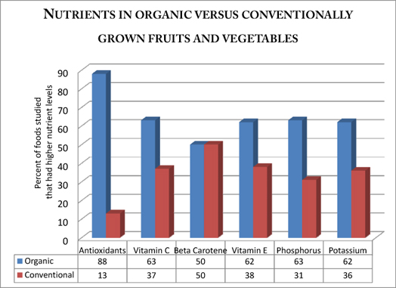Graph Courtesy of Dr. Lisa Watson 2008
Organics generally have a greater nutritional content over non-organics. Nevertheless, the immediate cost of these foods may shy some people away from them.

The Cost
Organics are growing in popularity, but still only account for “less than 4% of all foods purchased in the U.S.” due to the difference in production scales compared to conventionally grown foods (Mateljan, 2013). Because organics are not produced as much, a higher price is usually attached, though
Photo Courtesy of Justin Sullivan 2012
Organic Versus Non-Organic
sometimes you may find a minimal difference in cost because of location and season. However, the negative effects that can come from conventionally grown foods can bring higher costs to both the environment and to your health in the long run.
But in terms of immediate cost, Eve O’Neill, a consumer in California, investigated prices at a Whole Foods organic store and a Safeway, with 25 similar items from each store, and found about a $9 increase in price towards organics (2012). For 25 items, plus the aforementioned benefits of choosing organic, a $9 increase is not too bad. Some of the organic items were in fact slightly cheaper at Whole Foods versus Safeway too! The biggest difference in cost came from the meat prices, with organic chicken at Whole Foods being $3 more than Safeway. Seeing this $3 price difference actually makes one worry about the process involved for the Safeway meat to be that much cheaper. After seeing this example, it seems reasonable to pay a little extra for safer food.

Are Organics Better than Non-Organics?
Yes! Organic foods are healthier for you and not as harsh on the environment. Foods considered organic are superior to conventionally made food, they are more nutritious and safer towards us and the world we live in, and they really do not cost much more. The payoff for eating healthier and treating our world better brings a happier life when choosing organic foods.
Sources:
¹Mateljan, George. 2013. "Everything You Need to Know About Organic Foods." The George Mateljan Foundation. http://whfoods.org/genpage.php?tname=faq&dbid=17.
Benbrook, Charles, and Lisa Watson. 2008. "Is organic food really worth the extra cost?." The Organic Center. http://news.medill.northwestern.edu/chicago/news.aspx?id=92269.
O'Neill, Eve. 2012. The Billfold. http://thebillfold.com/2012/04/is-whole-foods-really-that-more-expensive/.
Sullivan, Justin, and Jason Mark. 2012. "Californian campaign pushes for labelling of GM food." Getty Images. http://www.guardian.co.uk/environment/2012/mar/12/californian-campaign-labelling-gm-food?INTCMP=SRCH.
